Computer Vision HW1

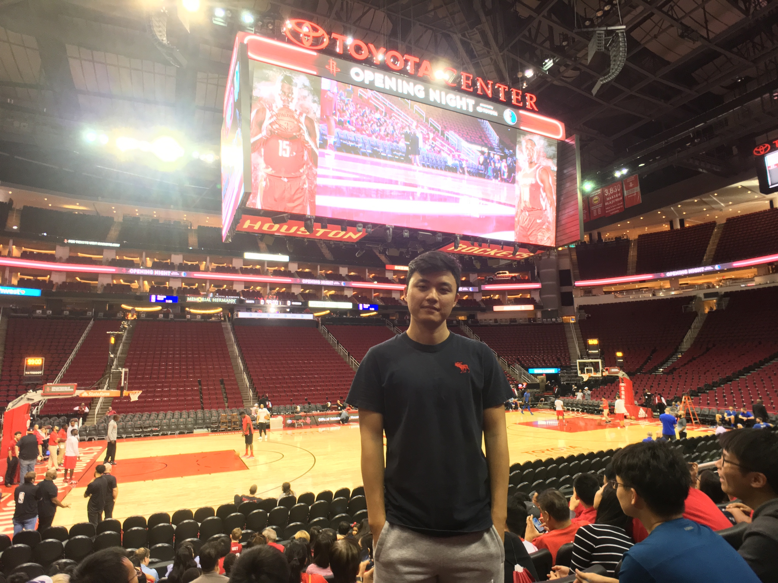Chien-Cheng Lai

ChBE

1. Part 1
2. Exercise 1

* Crop the head of the superhero from the image and save as PNG file.

(1:200, 230:400, :)



* Display the green component of the cropped image.



* Change the order of the color components to [Green,Red,Blue] for the original image. (imshow(im1(:,:,[2,1,3])))



1. Exercise 2

* Use *rgb2gray* to convert the image to gray scale.



* Plot a histogram of the gray scale image with bin-size of 5 pixels.



* Use *fspecial* and *imfilter* to blur the gray scale image by using Gaussian filters of size 15 × 15 with standard deviations 2 and 8. And plot the histogram.



Gaussian will filter out the signal on the both ends of the x-direction. However, the standard deviations increasing from 2 to 8 seems not to affect the signal much except on the small value x.

* Subtract the blurred image obtained using the filter with standard deviation of 2 from the original gray scale image.



* Threshold the resultant image at 5% of its maximum pixel value and display the final image.



There is not much difference between these two pictures. They both show contour of the picture. I think they probably filter out similar signal of the picture.

1. Part 2
2. Filter the following matrices I1 and I2 without using built-in MATLAB functions.

I1 = $\left[\begin{matrix}120 & 110 & 90 & 115 & 40 \\ 145 & 135 & 135 & 65 & 35 \\ 125 & 115 & 55 & 35 & 25 \\ 80 & 45 & 45 & 20 & 15 \\ 40 & 35 & 25 & 10 & 10\end{matrix}\right]$

I2 = $\left[\begin{matrix}125 & 130 & 135 & 110 & 125 \\ 145 & 135 & 135 & 155 & 125 \\ 65 & 60 & 55 & 45 & 40 \\ 40 & 35 & 40 & 25 & 15 \\ 15 & 15 & 20 & 15 & 10\end{matrix}\right]$

Use *padarray* to pad repeating border elements of array.

*PI1 = padarray(I1, [1,1], 'replicate')*

*PI2 = padarray(I2, [1,1], 'replicate')*

I choose to use replicate because I think it is more suitable in this case. They become:

I1 = $\left[\begin{matrix}120 & 120 & 110 & 90 & 115 & 40 & 40 \\ 120 & 120 & 110 & 90 & 115 & 40 & 40 \\ 145 & 145 & 135 & 135 & 65 & 35 & 35 \\ 125 & 125 & 115 & 55 & 35 & 25 & 25 \\ 80 & 80 & 45 & 45 & 20 & 15 & 15 \\ 40 & 40 & 35 & 25 & 10 & 10 & 10 \\ 40 & 40 & 35 & 25 & 10 & 10 & 10\end{matrix}\right]$

I2 = $\left[\begin{matrix}125 & 125 & 130 & 135 & 110 & 125 & 125 \\ 125 & 125 & 130 & 135 & 110 & 125 & 125 \\ 145 & 145 & 135 & 135 & 155 & 125 & 125 \\ 65 & 65 & 60 & 55 & 45 & 40 & 40 \\ 40 & 40 & 35 & 40 & 25 & 15 & 15 \\ 15 & 15 & 15 & 20 & 15 & 10 & 10 \\ 15 & 15 & 15 & 20 & 15 & 10 & 10\end{matrix}\right]$

Then apply the flowing 3 filters:

* Filter 1: $\frac{1}{3}\left[\begin{matrix}1 & 1 & 1\end{matrix}\right]$
* Filter 2: $\frac{1}{3}\left[\begin{matrix}1 \\ 1 \\ 1\end{matrix}\right]$
* Filter 3: $\frac{1}{9}\left[\begin{matrix}1 & 1 & 1 \\ 1 & 1 & 1 \\ 1 & 1 & 1\end{matrix}\right]$

The finally results:

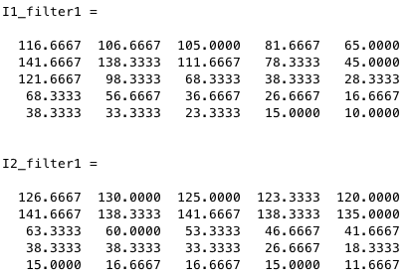

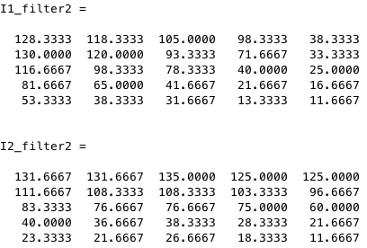

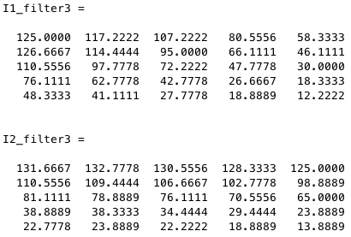

1. Apply following filters on the gray scale image of barbara from Part I.

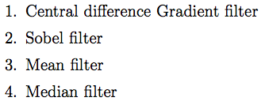

The functions I use are below:

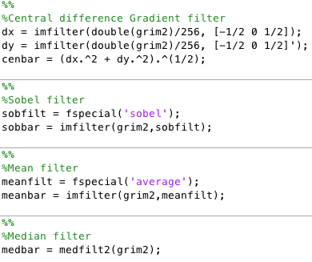

The result:



1. Smoothing

* Average

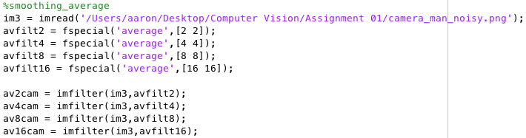

* Gaussian

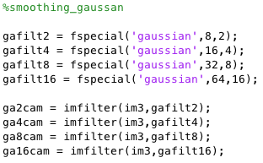

The results:





It’s hard to say which one is better in this case. But I think the Average filter is slightly better than Gaussian filter since it has less effect on the edge of the picture.

When I increase the box filter size, the picture becomes more blur. In the similar way, when I increase the standard deviation of gaussian filter, the picture becomes more blur too.

1. Edge preserving smoothing

Function:

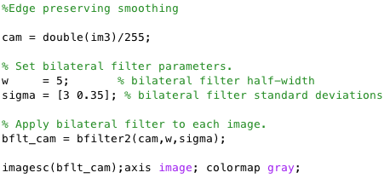

Result:



If we choose the large intensity standard deviation, the picture would become very blurred, otherwise, with the small intensity standard deviation, the effect of the filter on the picture becomes small as well.

In this case, I think 0.35 is a good choice, the picture won’t be too blurred and also filter out much noise.